Assignment – 3

* **Connecting of static routing with 4 routers.**
* Procedure:

Step 1 : Take 4 Routers (Router0, Router1, Router2, Router3), 4 Switches

(Switch0-Switch3), 8 PCs (PC0-PC7)

Step 2 : Connect the 4 Routers, 4 Switches, 7 PC’s:

Step 2.1 : Router0 → Router1 → Router2 → Router3

Step 2.2 : Router0 → Switch0, Router1 → Switch1,

Router2 → Switch2, Router3 → Switch3

Step 2.3 : And all the PC’s connected to the switches like in diagram

Step 3 : Assign separate IP Address, Subnet Mask, and Default Gateway to

each PC in class C & also configure the Gateway of each PC i.e. the private IP Address of Router’s.

Step 4 : Now set the routing for each Router by adding Network, Mask, Next Hop

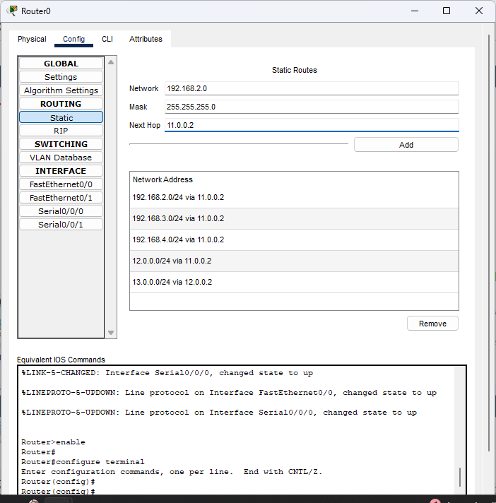just like that and do it for every router (Router0, Router1, …, Router4):

Step 4 : Test the Network Connection.

Open any PC’s Command Prompt and ping another PC’s IP Address.

Step 5 : If replies are successful, the connection works!

* 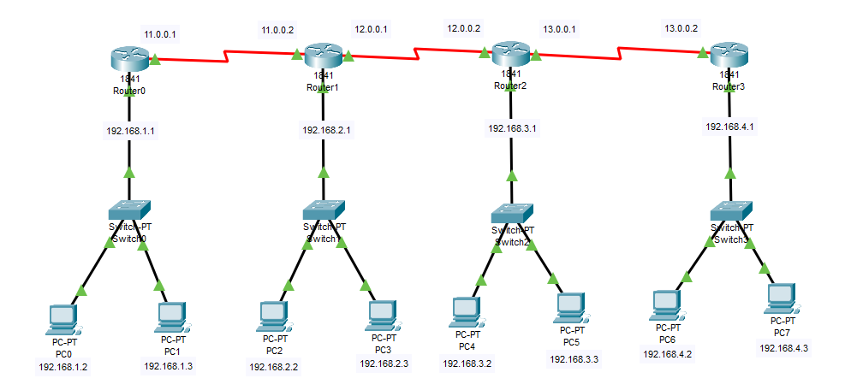Diagram:
* Output’s:

